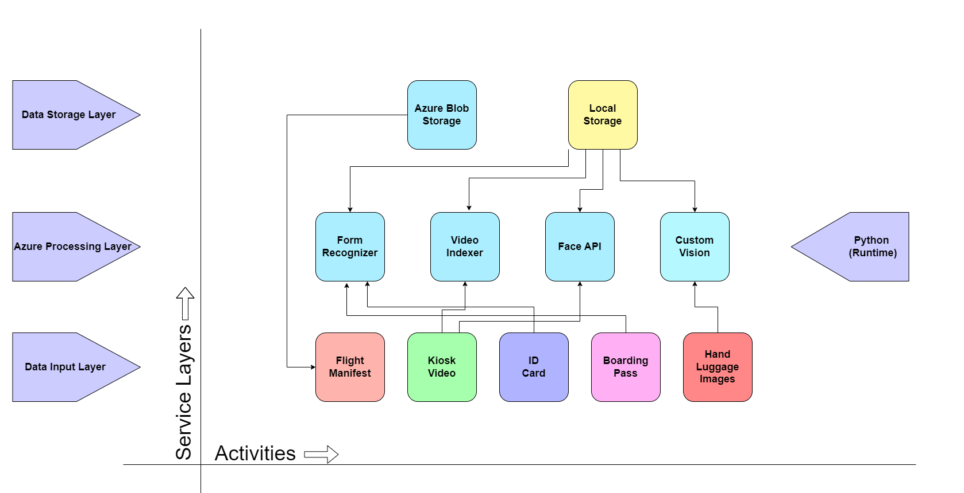Project Architecture

**How to follow the Guideline as shown in above example:**

* The activities and components include the Flight Manifest, ID card, Kiosk video, boarding pass, and hand luggage images
* The system will use Azure services such as Custom Vision, Form Recognizer, Face API and Video Indexer.
* Most of the information will be stored locally, and the Flight Manifest will be stored in Azure Blob Storage.
* There are three main layers – Data Storage, Azure Processing and Data Input:
  + Data Storage includes the Azure Blob Storage and Local Storage.
  + Azure Processing includes Custom Vision, Form Recognizer, Face API and Video Indexer.
  + Data Input such as Flight Manifest, ID card, Kiosk video, boarding pass and hand luggage images.
* For the system to run properly, we need to connect these components so that they are able to interact with one another succesfully.